Type of the article: original
Title of the article: Herpes zoster ophthalmicus: Clinicodemographic characteristics and Outcomes of 64 Egyptian patients.
Running title: Clinicodemographic features of HZO
Mohammed Abu El-Hamd, MD¹ and Soha Aboeldahab, MD¹
¹ Department of Dermatology, Venereology and Andrology, Faculty of Medicine, Sohag University, Upper Egypt.

Corresponding author
Dr. Mohammed Abu El-Hamd, MD
Email: mohammedadva@yahoo.com
Assistant Professor of Dermatology, Venereology and Andrology, Faculty of Medicine, Sohag University, Sohag, 82524, Egypt.
Phone: 01004139060.
Number of pages (19), Total words (4229), Abstract (250) Tables (2), Figure (5)
Acknowledgment: We are grateful to all the faculty and postgraduates in our scientific departments for their invaluable help in conducting this study.
There is no conflict of interest. There is no financial support from any institute or company.
The manuscript has been read and approved by all the authors. All the authors had the same contribution in conducting this manuscript.

Abstract
Background: Herpes zoster ophthalmicus (HZO) accounts for 10-20% of all patients with herpes zoster. Objectives: This study aimed to evaluate demographic features, clinical presentations, and outcomes of HZO patients.
Methods: In a prospective cross-sectional clinical study, it included 64 patients with clinically evident HZO. All patients underwent a detailed medical history and complete dermatological and ophthalmological examinations. Results: This study included 64 patients with HZO; 41 (64.1%) were females and 23 (35.9%) were males. Of female patients with HZO, 30 (73.2%) were married, 20 (48.7%) were urban, 35 (85.4%) were housewives, 17 (41.4%) had medium socioeconomic levels, 41 (100%) were nonsmokers, 13 (31.70%) had diabetes mellitus, 6 (14.63%) had hypertension, 30 (73.2%) had eruption on the left side, 11 (26.8%) had conjunctivitis and lid edema, 13 (31.7%) had post-herpetic neuralgia (PHN), 29 (70.7%) had post- treatment scars, and 6 (14.6%) had a reduced visual outcome. Of male patients with HZO, 20 (87%) were married, 12 (52.2%) were suburban, 7 (30.4%) were worker, 14 (60.9%) had low socioeconomic levels, 15 (65.2%) were smokers, 8 (34.8%) had diabetes mellitus, 1 (4.3%) had hypertension, 18 (78.3%) had eruption on the left side, 9 (39.16%) had conjunctivitis and lid edema, 7 (30.4%) had PHN, 10 (43.5%) had post HZO cutaneous scarring and 4 (17.4%) had a reduced visual outcome.
Limitations: The sample size of this study was small.
Conclusion: This study concluded that HZO is a common and potentially ruinous disease that may show a significant ophthalmic morbidity if not adequately diagnosed and treated.
Keywords: demographic features, herpes zoster, herpes zoster ophthalmicus.
Introduction:
Herpes zoster (HZ) is a reactivation of the varicella zoster virus (VZV), most commonly presented in the elderly and immunosuppressed patients, with incidence estimates ranging from 1.25 to 5.25 per 1,000 person-years.¹
Herpes zoster ophthalmicus (HZO) was defined as VZV infection within the ophthalmic division of the fifth cranial nerve. HZO accounts for 10-20% of all patients with HZ.²
HZO occurs when reactivation of the latent virus in the trigeminal ganglia involves the ophthalmic division of the nerve. The virus has gangrenous effects on the eye and surrounding structures by secondary perineural and intraneural inflammation of sensory nerves.³
Age and race appear to be essential demographic features in determining the risk of HZO.⁴ The incidence and prevalence of HZO appeared to be increasing due to reasons cited include an older population with inherent immune senescence, immunosuppression by pharmacotherapy, immunocompromising diseases such as acquired immune deficiency syndrome (AIDS), and universal varicella vaccination in the young leading to fewer exposures within the community to maintain cell mediated immunity. ⁵
The prodromal phase of HZO includes fatigue, malaise and low-grade fever that lasts up to one week before the rash over the forehead appears.⁶ About 60 % of patients have several degrees of dermatomal pain in the distribution of the ophthalmic nerve.⁷ Subsequently, erythematous macules appear along the involved dermatome then rapidly progressing over several days to papules and vesicles containing clear serous fluid and later pustules. These lesions rupture and typically crust over, requiring several weeks to heal.⁸
Although no vesicular eruption was present at initial neuro-ophthalmic consultation many features suggested HZO: 1) dermatome of fifth cranial nerve distribution of pain; 2) partial pain relief with palpation; 3) lack of other symptoms to suggest giant cell arteritis; and 4) normal acute phase reactant levels.⁹
HZO can be classified into HZO with or HZO without eye affection.² In the era of pre-antiviral treatment, approximately 50% of patients with HZO developed ocular involvement.¹⁰
The most common ophthalmic manifestations in HZO patients are keratitis, uveitis and conjunctivitis. Other manifestations include episcleritis and scleritis, acute retinal necrosis, cranial nerve involvement and/or meningoencephalitis.¹¹
Long-term structural complications including glaucoma, cataract, corneal scarring, and post herpitic neurolagia (PHN) can have devastating outcomes on visual function and/or quality of life of the patients.¹¹
Antiviral drugs such as acyclovir, valacyclovir and famcyclovir remain the mainstay of therapy and are the most effective lines of treatment in preventing ocular affections when start within 72 hours after the onset of the skin rash.¹²
This study aimed to evaluate demographic features, clinical presentations and outcomes of HZO patients.

Patients and methods:
This study was a prospective cross-sectional clinical design. It included 64 patients with clinically evident HZO who attended to Clinics of Dermatology, Venereology and Andrology, Faculty of Medicine, Sohag University, Egypt or refereed from Clinics of Ophthalmology, Faculty of Medicine, Sohag University, Egypt. This study has been conducted between January 2017 and October 2018. Informed consents were obtained from all patients after detailed clarification for the nature of the study.
The diagnosis of HZO was based on an established clinical diagnosis and confirmed in all patients by two dermatologists. According to Oxman et al ¹³ and Gauthier et al ¹⁴ who defined PHN as pain that persists for at least 3 months after the onset of HZ rash.
Every patient underwent a full evaluation by dermatologist and ophthalmologist to verify the diagnosis of HZO and to detect ocular manifestations.
All patients underwent a detailed medical history included; age, sex, education, occupation, marital status, residence, social class, special habits, past history of chickenpox, past history of HZ, history of receiving immunosuppressive drugs, history of medical illness, and history of psychological stress before eruption.
All patients underwent full clinical assessment of HZO disease included; site of the disease, pain, rash, (onset, course and duration of the disease), eye affections, visual outcomes after treatment, PHN and post- treatment scar.
All patients received systemic antiviral drugs (for 7-10 days), non-steroidal anti-inflammatory drugs and topical drugs for the cutaneous and eye lesions.

Statistical analysis:
Statistical analysis has been performed using the IBM Statistical Package for Social Sciences, version 20.0 (SPSS Inc., Chicago, IL, USA). Quantitative data was presented as the mean ± standard deviation, and qualitative data was presented as frequency and percentages. Student t-test was used for comparison between quantitative data of the study groups. P < 0.05 was considered statistically significant.
Results:
This study included 64 patients with clinically evident HZO; 41 (64.1%) were females and 23 (35.9%) were males. The mean age of female patients was 53.14± 14.24 and mean age of male patients was 52.56±12.44. There was no significant difference in the mean ages of the females and males (P = 0.93). (Table 1)
Thirty (73.2%) of female patients were married and 20 (87%) of male patients were married. Of female patients, 15 (36.6%) were not educated and 9 (22%) were secondary school. Of male patients, 7 (30.4%) were not educated and 5 (21.7%) were university graduate. Of female patients, 35 (85.4%) were housewives and 3 (7.3%) were teacher. Of male patients, 7 (30.4%) were worker and 6 (26.1%) were not working. (Table 1)
20 (48.7%) of female patients were urban and 12 (52.2%) of male patients were suburban.
17 (41.4%) of female patients had medium socioeconomic levels and 14 (60.9%) of male patients had low socioeconomic levels. 41 (100%) of female patients were nonsmokers and 15 (65.2%) of male patients were smokers. (Table 1)
35 (85.4%) of female patients and 20 (87%) of male patients had no past history of chickenpox. 41 (100%) of female patients and 23 (100%) of male patients had no a past history of HZ. 40 (97.6) of female patients and 23 (100%) of male patients had no a history of receiving immunosuppressive drugs. (Table 2)
Of female patients with HZO, 13 (31.70%) had diabetes mellitus and 6 (14.63%) had hypertension. Of male patients with HZO, 8 (34.8%) had diabetes mellitus and 1 (4.3%) had hypertension. 22 (53.7%) of female patients and 11 (47.8%) of male patients had a history of psychological stress before eruption. (Table 2)
Of female patients with HZO, 30 (73.2%) had eruption on the left side and 11 (26.8%) eruption on the right on side. Of male patients with HZO, 18 (78.3%) had eruption on the left side and 5 (21.7%) had eruption on the right on side. 41 (100%) of female patients and 23 (100%) of male patients had a pain. 41 (100%) of female patients and 23 (100%) of male patients had a gradually onset and progressive course. (Table 2) (Figure 1,2,3,4 )
The mean duration of the HZO of female patients was 4.83± 1.53 and mean duration of the HZO of male patients was 5.56± 1.23. There was no significant difference in the mean duration of the HZO between females and males patients (P = 0.17). (Table 2)
Of female patients with HZO, 19 (70.8%) had no eye manifestations and 11 (26.8%) had conjunctivitis and lid edema. Of male patients with HZO, 13 (56.5%) had no eye manifestations and 9 (39.16%) had conjunctivitis and lid edema. Optic neuritis was presented at 1 (2.43%) of female patient and 1 (4.34%) of male patient. (Table 2)
Of female patients with HZO, 35 (85.4%) had a normal visual outcome and 6 (14.6%) had a reduced visual outcome. Of male patients with HZO, 19 (82.6%) had a normal visual outcome and 4 (17.4%) had a reduced visual outcome. 13 (31.7%) of female patients and 7 (30.4%) of male patients had post-herpetic neuralgia. 29 (70.7%) of female patients and 10 (43.5%) of male patients had post HZO cutaneous scarring. (Table 2) (Figure 5)
Discussion:
To the best of our knowledge, this was the first study aimed to evaluate the demographic features, clinical presentations and outcomes of HZO patients who attended Outpatient Clinics of the Dermatology, Venereology, and Andrology Department, Faculty of Medicine, Sohag University, Egypt.
Of 64 patients with HZO, 41 (64.1%) were females and 23 (35.9%) were males. This finding concurs with Tran et al who reported that distribution of HZO according to sex was approximately 59.9% female and 40.1% male.¹⁵ Generally, females are exposed to more stressful conditions than males (menstruation, pregnancy and lactation) that are the triggers for reactivation of latent VZV and also females are good observers to abnormal sensation they feel or abnormal rash.
In the current study, the mean age of male patients was (52.56±12.44) while the mean age of female patients with HZO was (53.14± 14.24). Ghaznawi et al¹⁶ reported that HZO was more frequent in individuals between the ages of 60-69 years while Miserocchi et al¹⁷ found that HZO was more frequent in patients between the ages of 50-59 years.
In this study, HZO was more common among married male patients (87%) and married female patients (73.2%). Marriage is always associated with many social and economic troubles which expose the partners to more stressful conditions that impair the immunological status of the patients.
In the current study, 69.6% of male patients and 63.4% of female patients with HZO were educated. This study reported that detection of HZO associated with increase the level of education reflects that education may associated with more awareness of the disease that leading to a higher level of early seeking medical advice.
This study reported that HZO was a common in housewife females 85.4% which may be explained by that housewives are more liable to psychological problems and depression than working females whom are economically independent from their husbands. Depression may be influencing HZ risk through the mechanism of decreasing the cell mediated immunity; depression was found to be associated with decline in VZV-specific cell-mediated immunity as measured by the VZV responder cell frequency.¹⁸
In our study, 60.8% of male patients with HZO had non-official jobs (drivers, farmers and workers). Exposure to environmental factors such as pollution, chemicals, sun and stress (because they hadn’t fixed salary) may explain higher incidence of HZO among these patients than others. The most common risk factors that can result in inadequate immune response to VZV reactivation at any age, including mental health, stress, co-morbid infections (e.g., cytomegalovirus infection) and chemotherapy, and disease-related immunosuppression (e.g., HIV-AIDS).¹⁹
In the current study, 78% of female patients and 87% of male patients with HZO were from rural and suburban areas. Nowadays, the level of education and awareness increased in these areas in our community so they seek medical advice early.
This study found that 82.6% of male patients and 78% of female patients with HZO were of low and middle socioeconomic class; these both classes in our community suffer from many economic and social problems making them more liable for diseases than others.
The current study reported that 65.2% of male patients with HZO were current smokers. Tobacco is considered the most commonly used addictive substance in Egypt. Smoking has deleterious effects on both systemic and local immunity, which may lead to reactivation of latent virus .Smoking may particularly synergize with aging to increase the prevalence of HZO. Cigarettes, chemicals and pesticides have been associated with increase the risk of HZ.²⁰
In the current study, 85.4% of female patients and 87% of male patients with HZO had no previous history of chicken pox. It may be related to the non-specific symptoms and signs of chicken pox in most of the patients, so may pass unnoticed by parents beside that the disease is self limited and most of these patients may consult general practitioners not dermatologists. de Melker et al found in a non-vaccinated population such as the Netherlands, the risk of acquiring a primary VZV infection is over 97% and most people contract varicella before the age of five.²¹ Varicella infection is necessary for herpes zoster.²
In this study, none of the patients had history of previous attack of HZ which was similar to Mona Marin et al. who detected the personal history of previous HZ attack as a risk factor for current HZ was usually ignored, and recurrence of HZ was considered uncommon.²²
This study showed that 48.79% of female patients and 39.2% of male patients with HZO had history of medical systemic diseases (diabetes mellitus, hypertension and renal transplantation). Opstelten et al ²³ showed that the main factors affecting epidemiology of HZO were epidemiology of associated systemic diseases, use of immunosuppressant drugs and implementation of both the varicella and zoster vaccines.
In this study, only one female patient with HZO had history of receiving immunosuppressive drugs after renal transplantation (high doses of corticosteroid and azathiopurine). Edell et al. found immunosuppression and the immunosenescence of aging have been associated with an increased risk of developing HZ. ²⁴
This study found that 53.7% of female patients and 47.8% of male patients with HZO had history of psychological stress before eruption. Lasserre et al ²⁵detected that less consistency can be found regarding stress as a risk factor for HZ but Mona Marin et al ²² found that stress in the 3 months before HZ was considered a risk factor, but there was no evidence of a dose response.
This study found that HZO had acute onset and progressive course in all patients. The mean duration of HZO in male patients (5.56 ± 1.23) was longer than in female patients (4.38 ± 0.57).
In this study, the most common site of HZO was the left side in 73.2% of female patients and 78.3% of male patients.
This study reported that periorbital vesicular rash was presented in all patients which was inconsistent with Borkar et al who reported that dermatitis was the most common manifestation overall of HZO and more than 60% of the patients presented with dermatitis without any other manifestations.⁴
All the patients had history of pain at time of presentation. Harding et al found that pain is common at presentation, occurring in 82.1% of patients and of those who were pain free at presentation 60% subsequently developed pain.¹⁰
In current study, 29.2% of female patients and 43.5% of male patients with HZO developed ocular manifestations (conjunctivitis, keratitis, lid edema and optic neuritis). Liesegang reported 50% to 72% of patients with HZO had ocular involvement.² Keratitis and conjunctivitis had been reported as common manifestations of HZO.²⁶
In this study, visual outcome after treatment was normal in 85.4% of female patients and 82.6 % of male patients with HZO. Harding et al found that in the pre-antiviral era, 50% of patients with HZO developed ocular involvement.¹⁰ With antiviral therapy, lower frequencies of eye involvement had been reported, ranging from 2% to 29% .²⁷ If patients are not treated promptly and aggressively, HZO with intraocular involvement may lead to significant visual impairment.
In this study, 31.7% of female patients and 30.4% of male patients with HZO developed PHN. PHN is the most common chronic complication of HZ infection and is seen in 9%-45% of the patients. ²¹ But, other studies reported that the rate of developing PHN ranged between 5.4 and 19.5 % after all patients of HZ and ophthalmic location has been shown to be a risk factor for developing PHN ^{23, 27}, which may explain the slightly higher proportion of PHN found in this study. Also, this study found that the main risk factors of PHN are advanced age, the severity of acute zoster pain and ocular involvement.
In this study, post HZO cutaneous scarring was presented in 70.7% of female patients and 43.5% of male patients. The incidence of scar increased in dark skin complexion, advanced age, immunosuppression and severe extensive HZO eruption. El Hayderi et al. reported HZ was associated with cutaneous scarring in 9.7% of all cases and was common in females 56.3% than males 43.7%.²⁸
The present study has several limitations. The sample size was small because this study has been performed on outpatients in the dermatology clinics. In addition, multicenter studies are required to give more factually results of the demographic features, clinical presentations, possible risk factors and outcomes of HZO patients.
This study concluded that HZO is a common and potentially ruinous disease that may show a significant ophthalmic morbidity if not adequately diagnosed and treated.

References:
1. Cebrián-Cuenca AM, Díez-Domingo J, Rodríguez MS, Puig-Barberá J, Navarro-Pérez J; 'Herpes Zoster Research Group of the Valencian Community'. Epidemiology of herpes zoster infection among patients treated in primary care centres in the Valencian community (Spain). BMC Fam Pract 2010: 6; 11:33.
2. Liesegang TJ. Herpes zoster ophthalmicus natural history, risk factors, clinical presentation, and morbidity. Ophthalmology 2008; 115(2):S3-12.
3. Naumann G, Gass JD, Font RL. Histopathology of herpes zoster ophthalmicus. Am J Ophthalmol 1968; 65:533-41.
4. Borkar DS, Tham VM, Esterberg E, Ray KJ, Vinoya AC, Parker JV, et al. Incidence of herpes zoster ophthalmicus: results from the Pacific Ocular Inflammation Study. Ophthalmology 2013; 120(3):451-56.

5. Kawai K, Gebremeskel BG, Acosta CJ. Systematic review of incidence and complications of herpes zoster: towards a global perspective. BMJ Open 2014: 10; 4(6):e004833.
6. Goh CL, Khoo L. A retrospective study of the clinical presentation and outcome of herpes zoster in a tertiary dermatology outpatient referral clinic. Int J Dermatol 1997; 36:667-72.
7. Cobo M, Foulks GN, Liesegang T, Lass J, Sutphin J, Wilhelmus K, et al. Observations on the natural history of herpes zoster ophthalmicus. Curr Eye Res 1987;6:195-9.
8. Burgoon CF, Burgoon JS, Baldridge GD. The natural history of herpes zoster. J Am Med Assoc 1957; 164(3):265-9.

9. Sigireddi RR, Lyons LJ, Beaver HA, Lee AG. Herpes zoster ophthalmicus: Pre-eruption phase sine herpete. Am J Ophthalmol Case Rep 2018; 10: 201-202.
10. Harding SP, Lipton JR, Wells JC. Natural history of herpes zoster ophthalmicus: predictors of postherpetic neuralgia and ocularinvolvement. Br J Ophthalmol 1987; 71(5):353-8.
11. Yawn BP, Wollan PC, St Sauver JL, Butterfield LC. Herpes zoster eye complications: rates and trends. Mayo Clin Proc 2013;88(6):562–70.

12. Shaikh S, Ta CN. Evaluation and management of herpes zoster ophthalmicus. Am Fam Physician 2002: 66(9):1723-30.
13 Oxman MN, Levin MJ, Johnson GR, Schmader KE, Straus SE, Gelb LD, et al. A vaccine to prevent herpes zoster and postherpetic neuralgia in older adults. N Engl J Med 2005: 352:2271-84
14.Gauthier A, Breuer J, Carrington D, Martin M, Rémy V. Epidemiology and cost of herpes zoster and post-herpetic neuralgia in the United Kingdom. Epidemiol Infect 2009: 137:38-47
15. Tran KD, Falcone MM, Choi DS, Goldhardt R, Karp CL, Davis JL, et al. Epidemiology of herpes zoster ophthalmicus: recurrence and chronicity. Ophthalmology 2016; 123: 1469-75.
16. Ghaznawi N, Virdi A, Dayan A, Hammersmith KM, Rapuano CJ, Laibson PR, et al. Herpes zoster ophthalmicus: comparison of disease in patients 60 years and older versus younger than 60 years. Ophthalmology 2011; 118(11):2242-50.
17. Miserocchi E, Fogliato G, Bianchi I, Bandello F, Modorati G. Clinical features of ocular herpetic infection in an italian referral center. Cornea 2014;33 (6):565-70.
18. Irwin MR, Levin MJ, Carrillo C, Olmstead R, Lucko A, Lang N, et al. Major depressive disorder and immunity to varicella-zoster virus in the elderly. Brain Behav Immun 2011; 25:759-66.
19. Levin MJ. Zoster vaccine. In: Plotkin SA, Orenstein WA, Offit P, editors. Vaccine. Philadelphia: Elsevier Saunders; 2012. pp. 969-80.
20. Thomas SL, Hall AJ. What does epidemiology tell us about risk factors for herpes zoster? Lancet Infect Dis . 2004; 4:26-33.
21. de Melker H, Berbers G, Hahne S, Rümke H, van den Hof S, de Wit A, et al. The epidemiology of varicella and herpes zoster in The Netherlands: implications for varicella zoster virus vaccination. Vaccine 2006; 24:3946-52.

22. Marin M, Harpaz R, Zhang J, Wollan PC, Bialek SR, Yawn BP. Risk Factors for Herpes Zoster Among Adults. Open Forum Infect Dis 2016:3(3):ofw119.

23. Opstelten W, Mauritz JW, de Wit NJ, van Wijck AJ, Stalman WA, van Essen GA. Herpes zoster and postherpetic neuralgia: incidence and risk indicators using a general practice research database. Fam Pract 2002; 19:471-5.

24. Edell AR, Cohen EJ. Herpes simplex and herpes zoster eye disease: presentation and management at a city hospital for the underserved in the United States. Eye Contact Lens 2013; 39(4):311-14.

25. Lasserre A, Blaizeau F, Gorwood P, Bloch K, Chauvin P, Liard F, et al. Herpes zoster: family history and psychological stress-case-control study. J Clin Virol 2012; 55:153-7.
26. Puri LR, Shrestha GB, Shah DN, Chaudhary M, Thakur A. Ocular manifestations in herpes zoster ophthalmicus. Nepal J Ophthalmol. 2011; 3:165-71.
27. Hoang-Xuan T, Büchi ER, Herbort CP, Denis J, Frot P, Thénault S, et al. Oral acyclovir for herpes zoster ophthalmicus. Ophthalmology. 1992; 99(7):1062-70.
28. El Hayderi L, Nikkels-Tassoudji N, Nikkels AF. Incidence of and Risk Factors for Cutaneous Scarring after Herpes Zoster. Am J Clin Dermatol. 2018. doi: 10.1007/s40257-018-0385-2. [Epub ahead of print]

Table (1): Demographic features of patients with HZO.
Variable | Female patients with HZO (n₌41) | Male patients with HZO (n₌23)
Percentage (%) | 41 (64.1) | 23 (35.9)
Age
Mean±SD  P value | 53.14± 14.24 | 52.56±12.44
Mean±SD  P value | 0.93
Marital status, n (%)
Single  Married  Divorced | 10 (24.4) | 3 (13)
Single  Married  Divorced | 30 (73.2) | 20 (87)
Single  Married  Divorced | 1 (2.4) | 0
Education, n (%)
No  Primary  Elementary  Secondary school  University graduate | 15 (36.6) | 7 (30.4)
 | 6 (14.6) | 4 (17.4)
 | 4 (9.7) | 4 (17.4)
 | 9 (22) | 3 (13)
 | 7 (17.1) | 5 (21.7)
Occupation, n (%)
No  Housewife  Student  Officer  Worker  Teacher  Farmer  Driver | 0 | 6 (26.1)
 | 35 (85.4) | 0
 | 1 (2.4) | 0
 | 2 (4.9) | 1 (4.3)
 | 0 | 7 (30.4)
 | 3 (7.3) | 2 (8.7)
 | 0 | 4 (17.4)
 | 0 | 3 (13)
Residence, n (%)
Urban  Suburban  Rural | 9 (22) | 3 (13)
Urban  Suburban  Rural | 12 (29.3) | 12 (52.2)
Urban  Suburban  Rural | 20 (48.7) | 8 (34.8)
Socioeconomic level, n (%)
Low  Medium  High | 15 (36.6) | 14 (60.9)
Low  Medium  High | 17 (41.4) | 5 (21.7)
Low  Medium  High | 9 (22) | 4 (17.4)
Smoking, n (%)
No  Yes | 41 (100) | 8 (34.8)
No  Yes | 0 | 15 (65.2)
Data was expressed as mean± SD and number and percentage. Student t-test was used for comparison between quantitative variables of the study groups. P < 0.05 was considered statistically significant. HZO; herpes zoster ophthalmicus, SD; standard deviation.

Table (2): Clinical evaluation of patients with HZO.
Variable | Female patients with HZO (n₌41) | Male patients with HZO (n₌23)
Past history of chickenpox, n (%)
No  Yes | 35 (85.4) | 20 (87)
No  Yes | 6 (14.6) | 3 (13)
Past history of HZ, n (%)
No  Yes | 41 (100) | 23 (100)
No  Yes | 0 | 0
History of receiving immunosuppressive drugs, n (%)
No | 40 (97.6) | 23 (100)
Yes | 1 (2.4) | 0
History of medical illness, n (%)
No  Diabetes mellitus  Hypertension  Renal transplantation | 21 (51.21) | 14 (60.8)
No  Diabetes mellitus  Hypertension  Renal transplantation | 13 (31.70) | 8 (34.8)
No  Diabetes mellitus  Hypertension  Renal transplantation | 6 (14.63) | 1 (4.3)
No  Diabetes mellitus  Hypertension  Renal transplantation | 1 (2.43) | 0
History of psychological stress before eruption, n (%)
No  Yes | 19 (46.3) | 12 (52.2)
No  Yes | 22 (53.7) | 11 (47.8)
Site of the disease, n (%)
Left side  Right side | 30 (73.2) | 18 (78.3)
Left side  Right side | 11 (26.8) | 5 (21.7)
Pain, n (%)
No  Yes | 0 | 0
No  Yes | 41 (100) | 23 (100)
Rash, n (%)
No  Yes | 41 (100) | 23 (100)
No  Yes | 0 | 0
Onset, n (%)
Acute | 41 (100) | 23 (100)
Gradually | 0 | 0
Course, n (%)
Progressive | 41 (100) | 23 (100)
Stationary | 0 | 0
Regressive | 0 | 0
Duration of the disease
Mean±SD  P value | 4.83± 1.53 | 5.56± 1.23
Mean±SD  P value | 0.17
Eye manifestations, n (%)
No  Conjunctivitis, keratitis, lid edema  Optic neuritis | 19 (70.8) | 13 (56.5)
No  Conjunctivitis, keratitis, lid edema  Optic neuritis | 11 (26.8) | 9 (39.16)
No  Conjunctivitis, keratitis, lid edema  Optic neuritis | 1 (2.43) | 1 (4.34)
Visual outcomes after treatment, n (%)
Normal  Reduced | 35 (85.4) | 19 (82.6)
Normal  Reduced | 6 (14.6) | 4 (17.4)
Post-herpetic neuralgia, n (%)
No  Yes | 28 (68.3) | 16 (69.6)
No  Yes | 13 (31.7) | 7 (30.4)
Post HZO cutaneous scarring, n (%)
No  Yes | 12 (29.3) | 13 (56.5)
No  Yes | 29 (70.7) | 10 (43.5)
Data was expressed as mean± SD and number and percentage. Student t-test was used for comparison between quantitative variables of the study groups. P < 0.05 was considered statistically significant. HZ; herpes zoster, HZO; herpes zoster ophthalmicus, SD; standard deviation.

Figures legends:
Figure 1. 57 years old female patient with HZO.
Figure 2. 70 years old female patient with HZO.
Figure 3. 34 years old female patient with HZO.
Figure 4. 76 years old female patient with neglected HZO.
Figure 5. 25 years old female patient with post HZO cutaneous scarring.

Figure 1. 57 years old female patient with HZO.
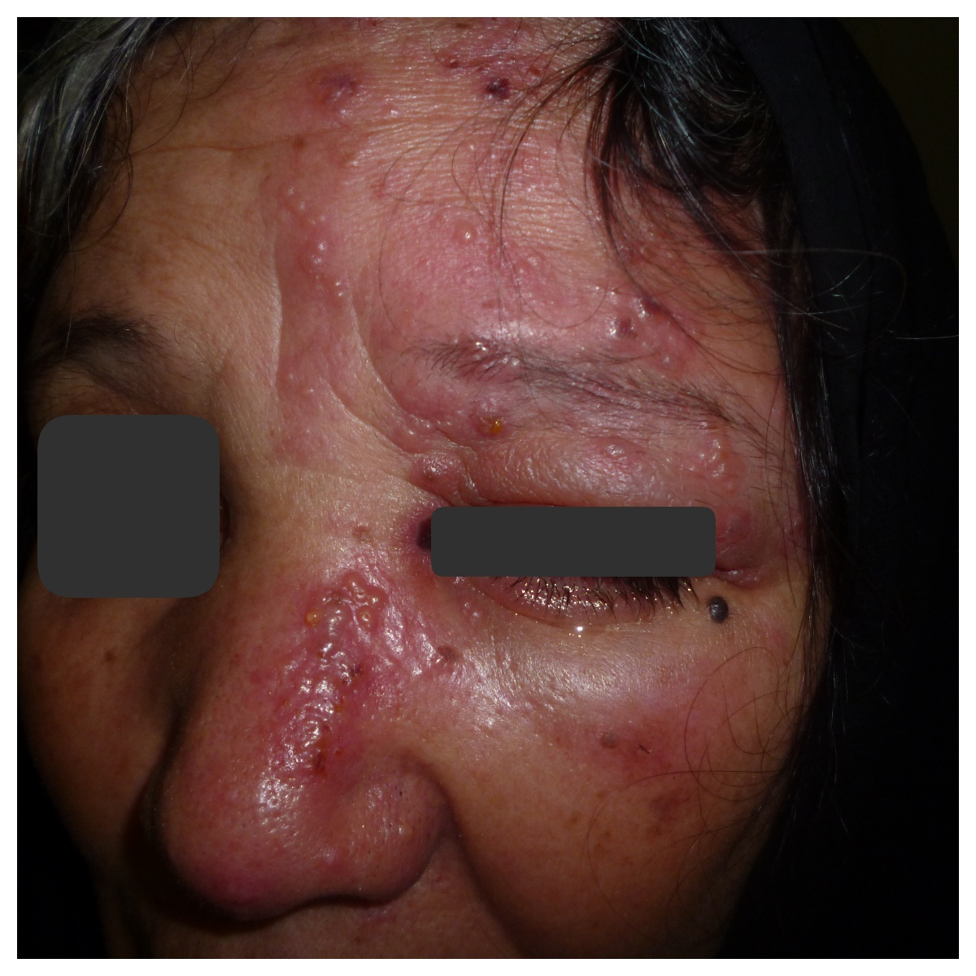

Figure 2. 70 years old female patient with HZO.
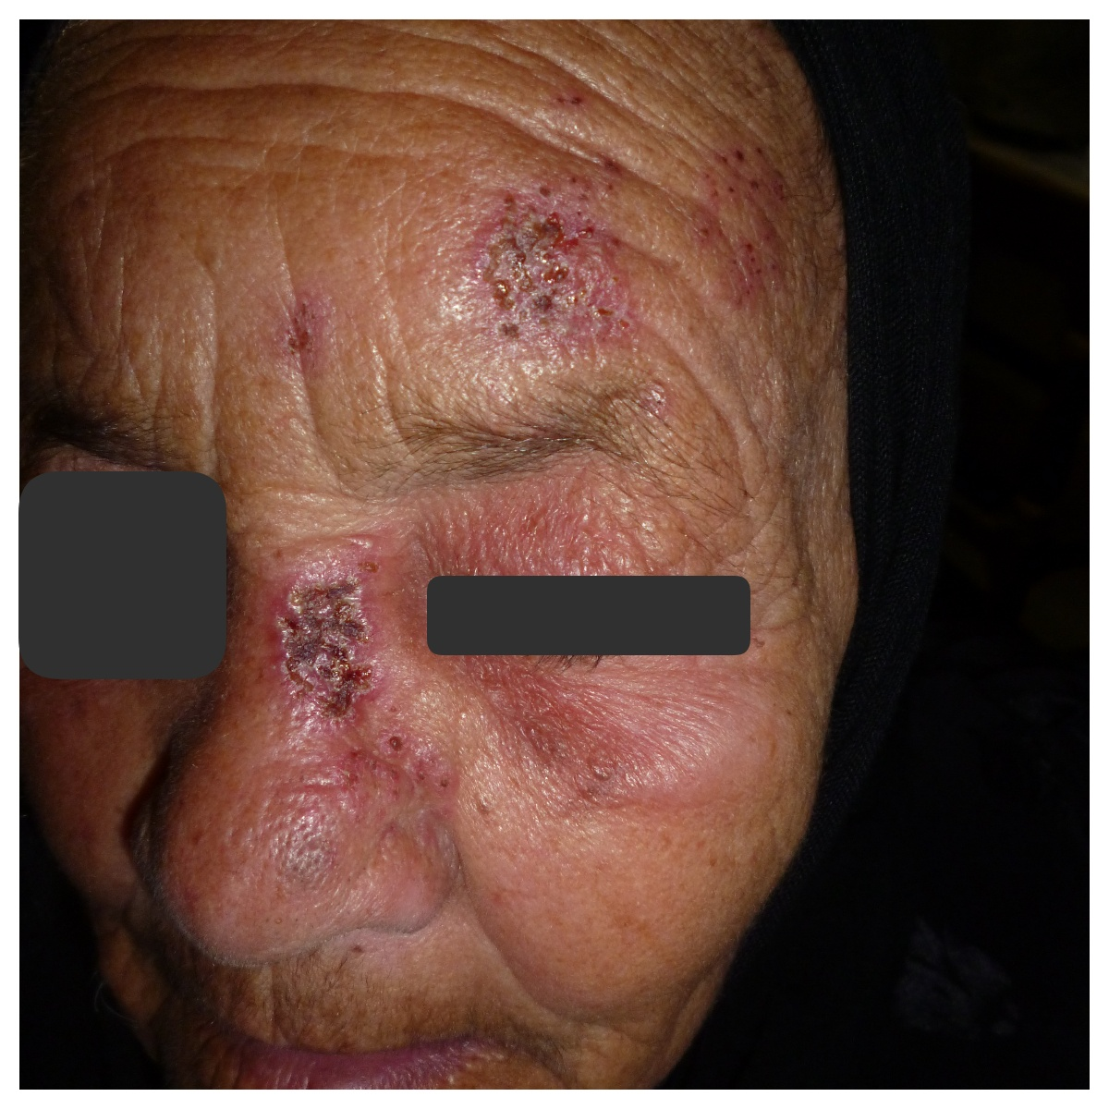

Figure 3. 34 years old female patient with HZO.

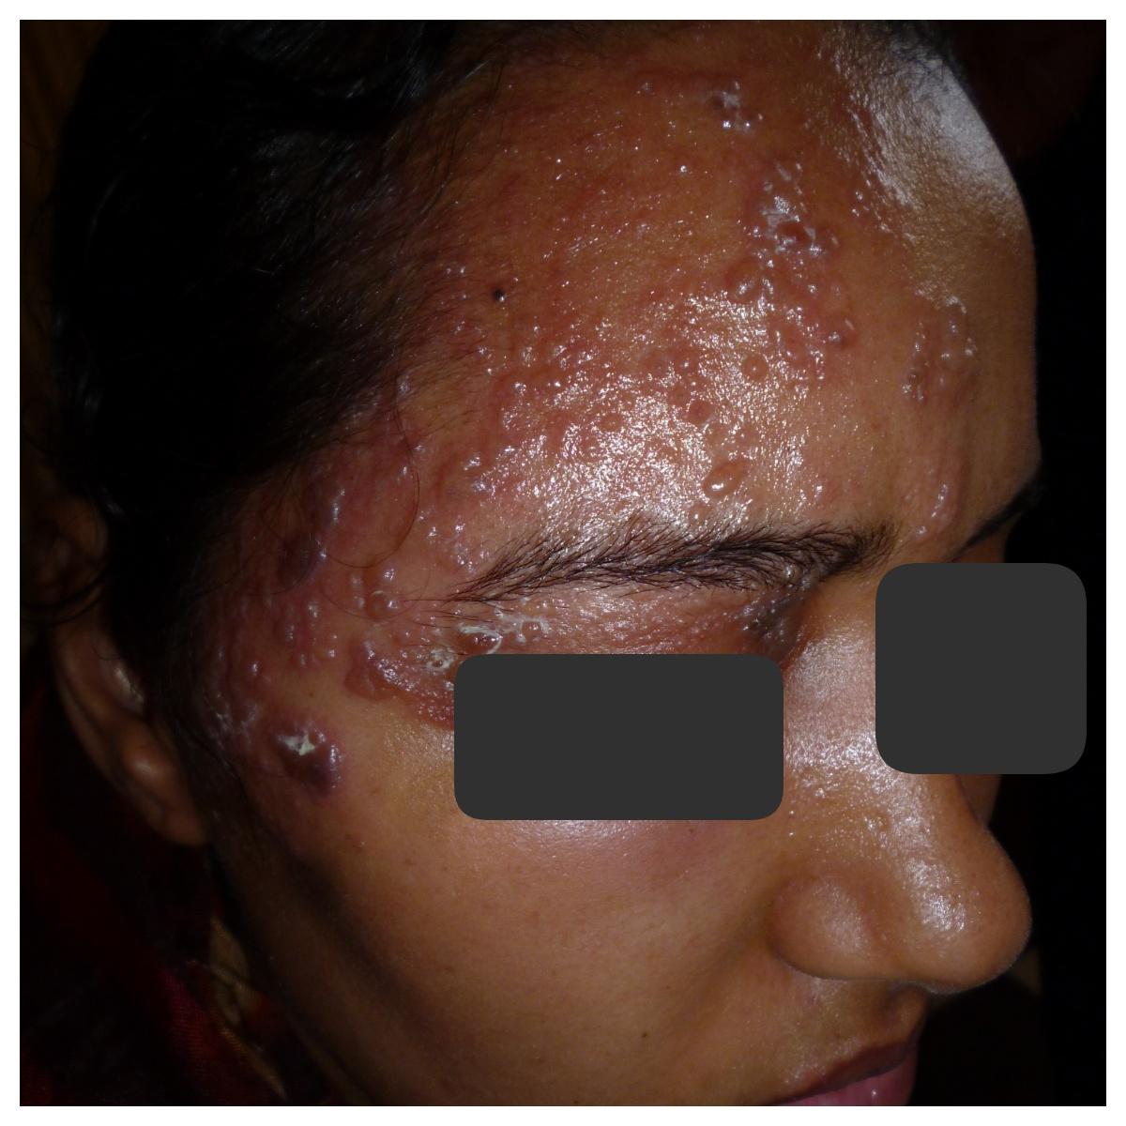

Figure 4. 76 years old female patient with neglected HZO.
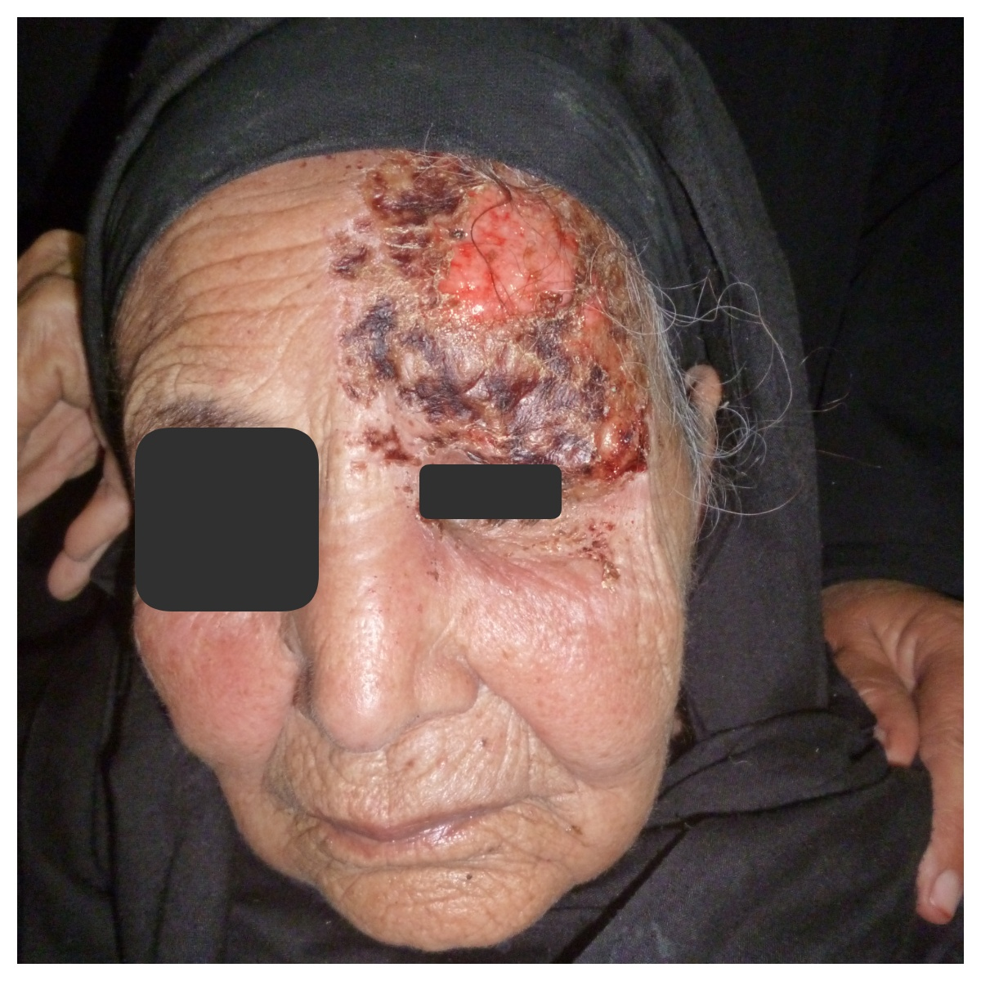

Figure 5. 25 years old female patient with post HZO cutaneous scarring.
